Assessment Test – 2

Name – Warish Kumar

Date – 15-04-2022

Question 1: Write the column name of Test Case & Bug Report.

Question 2: Write test case for Gmail Attachment & Rename Folder.

Question 3: Create a bug report for “Kuber Industeries” android

Application (Module: Search, Filter & Sort)

**Solution:**

1. (a) Column of Test Case:

|  |  |  |  |  |  |  |  |  |  |
| --- | --- | --- | --- | --- | --- | --- | --- | --- | --- |
| TC No. | Actor | Module | URL | Test Case description | OS | Browser | Steps | Test Data | Expected Result |
| Actual Result | Create by | Created date | Reviewed | Verify by | Verify date | Bug Id |  |  |  |

(b) Column of Bug Report:

|  |  |  |  |  |  |  |  |  |  |
| --- | --- | --- | --- | --- | --- | --- | --- | --- | --- |
| Bug Id | Actor | Module | URL | Bug Description | Steps | Test Data | OS | Browser | Actual Result |
| Assign | Priority | Status | Created by | Created date | Verify by | Verify date | Remarks/ Suggestion |  |  |

1. (a) Test Case of Gmail Attachment 📎
2. Verify when click on File attachment icon.
3. Verify when click on file attachment while internet is not available.
4. Verify when click on file attachment while internet is available.
5. Verify the default location of file explorer opened.
6. Verify when select all file of folder by pressing “Crtl + A”.
7. Verify when select multiple files with help of mouse.
8. Verify the maximum size of file that can attached.
9. Verify the minimum size of file that can attached.
10. Verify when select multiple files have different extension.
11. Verify when select multiple files have same extension.
12. Verify when switch on another location of file explorer.
13. Verify when upload invalid file extension (.ext, .bat, etc)
14. Verify when upload scripted file which have virus or vulnerable data.
15. Verify the name of file in file explorer which is selected.
16. Verify the name of file in file explorer when select multiple files.
17. Verify when upload music file (.mp3, .amr, .wav)
18. Verify when upload same file for multiple time.
19. Verify when upload again the previously removed file.
20. Verify when enter name of file in name field of file explorer which doesn’t exist in that location.
21. Verify when enter name of file in name field of file explorer which is available in that location.
22. Verify when internet go away during uploading file.
23. Verify when upload valid file type and click on send without any recipient & subject.
24. Verify when upload valid file type and click on send after enter recipient & subject.
25. Verify trim for file name search bar in same location.
26. Verify when drag and drop the file in attachment opened location.
27. Verify when drag and drop invalid file extension.
28. Verify when drag and drop valid file extension.
29. Verify when click on cancel button while uploading.
30. Verify when click on send button and internet go away.
31. Verify when drag and drop any folder.
32. Verify when junk files are drag and drop in attachment.
33. Verify when multiple files drag and drop have same extension of all files.
34. Verify when multiple files drag and drop having different extension of files.
35. Verify when drag and drop maximum size of file.
36. Verify when drag and drop minimum size of file.
37. Verify when drag and drop valid file in attachment field.

(b) Test Case of Rename Folder 📂

1. Verify rename folder when press f2.
2. Verify when double click on folder name.
3. Verify rename folder the command prompt.
4. Verify when right click on folder and select rename option.
5. Verify when keep the name of folder empty & press enter.
6. Verify when enter blank space in folder name.
7. Verify when enter special or junk character in folder name.
8. Verify when enter alphanumeric character in folder name.
9. Verify when enter only digits in folder name.
10. Verify when enter maximum character in folder name.
11. Verify when enter minimum character in folder name.
12. Verify trim for folder rename.
13. Verify to rename folder when that folder is open.
14. Verify to rename folder when it’s subfolder is opened.
15. Verify rename folder without name with special character as “Alt + 0160”.
16. Verify when folder is close but the content inside of folder is opened.
17. Rename the folder with reserved keyword.
18. Bug Report of Kuber Industry.

**Bug Id:** 1

**Module:** Search

**Bug Description:** When enter space between two character of searching keyword.

**Steps: 1)** Click on View All for any category from the dashboard.

**2)** Click on Search Icon

**3)** Enter character with space between them.

**Test Data:** B AG

**Expected Result:** It should show the item related to bag.

**Bug Image:**

**Bug Id:** 2

**Module:** Search

**Bug Description:** When extra word which doesn’t exist in product name, it’s doesn’t show that product.

**Steps: 1)** Click on View All for any category from the dashboard.

**2)** Click on Search Icon

**3)** Enter product name with extra word.

**Test Data:** White Bag, Bag under-price 500.

**Expected Result:** It should show product accordingly.

**Bug Image:**

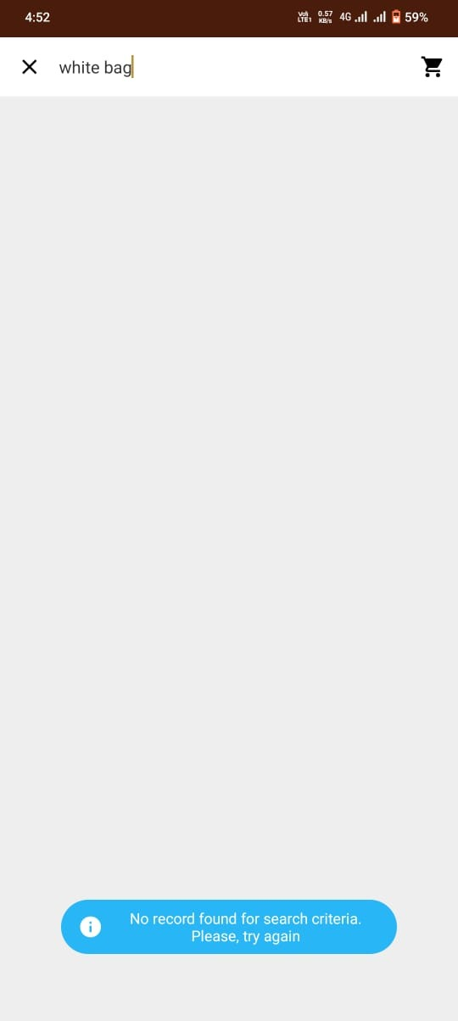

**Bug Id:** 3

**Module:** Search

**Bug Description:** Validation message is not meaningful.

**Steps: 1)** Click on View All for any category from the dashboard.

**2)** Click on Search Icon

**3)** Enter invalid name or name that doesn’t exit.

**Test Data:** White Bag, Bag under-price 500.

**Expected Result:** It should show product accordingly.

**Suggestion :** In validation, problem shown clearly. Even it’s always throw same message.

**Bug Image:**

**Bug Id:** 4

**Module:** Search

**Bug Description:** Validation message disappear after few seconds.

**Steps: 1)** Click on View All for any category from the dashboard.

**2)** Click on Search Icon

**3)** Enter invalid name & Click on search .

**Test Data:** White Bag.

**Expected Result:** Validation message should appeared until not fulfil the required criteria.

**Suggestion :** Validation message font and it’s background color is not proper visible.

**Bug Image:**

**Bug Id:** 5

**Module:** Sort

**Bug Description:** None of sorting option is working, but it reload.

**Steps: 1)** Click on View All for any category from the dashboard.

**2)** Click on Sort

**3)** Select any Option [Name(A -Z), Name(Z-A), Price( Low-

Hight), Price (High-Low)]

**Test Data:**

**Expected Result:** Item should be sorted according to option selected to sort.

**Suggestion :** All sorting functionality show work according to its name convention.

**Bug Image:**

**It’s always remain same dashboard or other item positon after applying all sorting option**

**Bug Id:** 6

**Module:** Sort

**Bug Description:** When change the sorting option multiple time rapidly, application get crashed or slow.

**Steps: 1)** Click on View All for any category from the dashboard.

**2)** Click on Sort

**3)** Select any Option [Name(A -Z), Name(Z-A), Price( Low-

Hight), Price (High-Low)] for multiple times

**Test Data:**

**Expected Result:** System should not crashed or slow down.

**Suggestion :**

**Bug Image:**

**Bug Id:** 7

**Module:** Filter

**Bug Description:** Colour filter is available twice for all products.

**Steps: 1)** Click on View All for any category from the dashboard.

**2)** Click on Filter

**Test Data:**

**Expected Result:** Colour filter should be only one for all products.

**Suggestion:** Keep the either name of colour or colour itself. Or it can be kept together at same place.

**Bug Image:**

**Bug Id:** 8

**Module:** Filter

**Bug Description:** When we select different colour in same product, then no product preview and none of validation message appear.

**Steps: 1)** Click on View All for any category from the dashboard.

**2)** Click on Filter

**3)** Select from “colour” option

**4)** Select from “colour Filter” option d/f from colour

**Test Data:**

**Expected Result:** It should fire validation message for the no product review.

**Suggestion:**

**Bug Image:**

